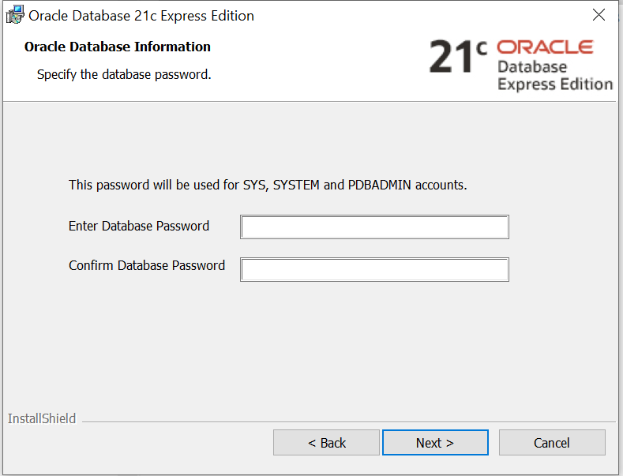

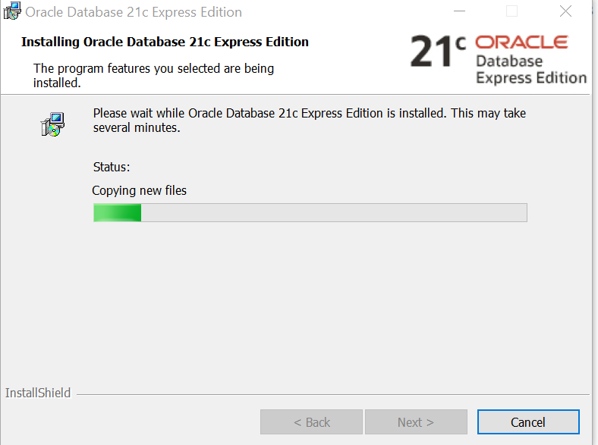

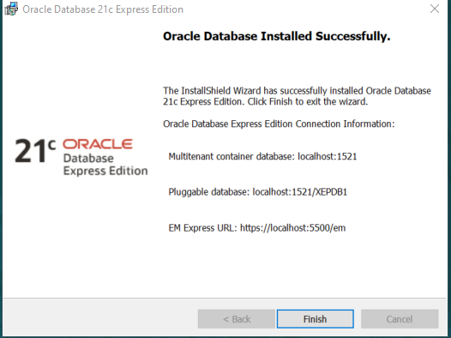

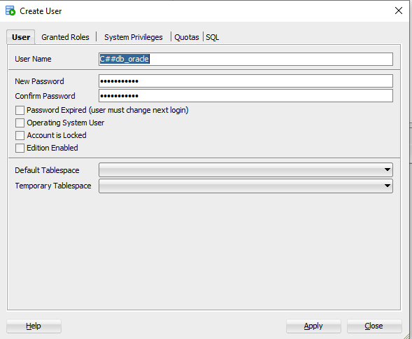

Or syntax CREATE USER "C##db_oracle" IDENTIFIED BY "password" ;

After instaling Oracle Database, we need SQL Developer

Download SQLDeveloper

Creare conectare SQL Developer

<https://www.youtube.com/watch?v=58V-w3buWm4>

**Service name** (?): xepdb1

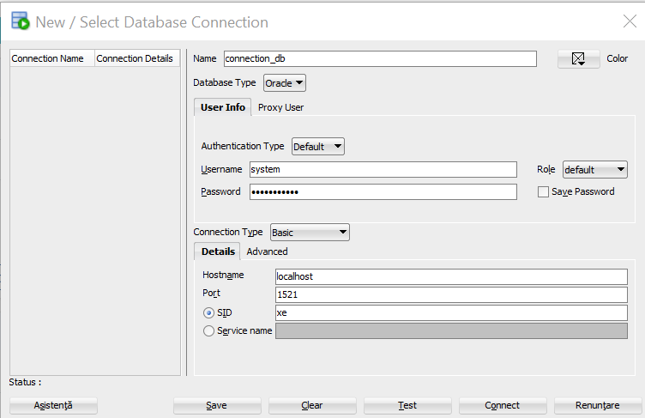

Create new user from Other Users

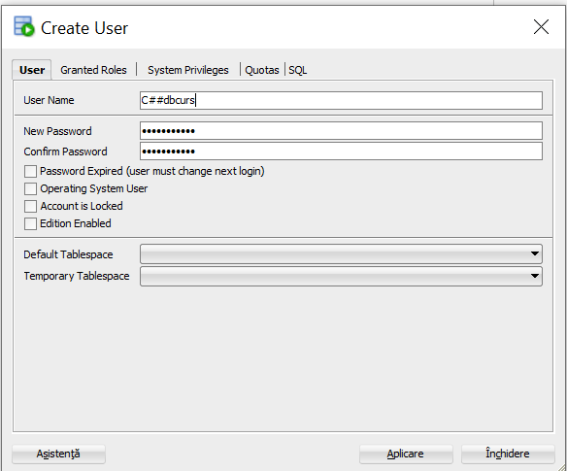

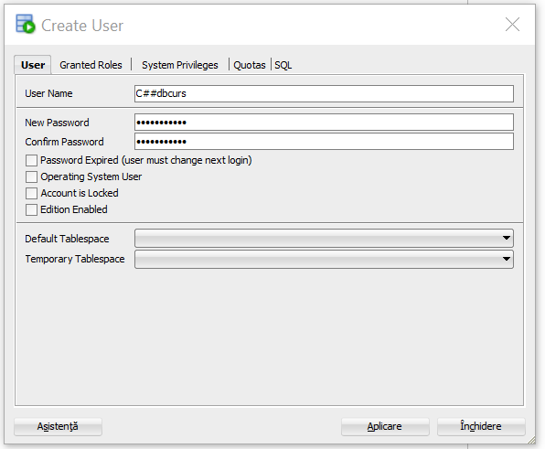

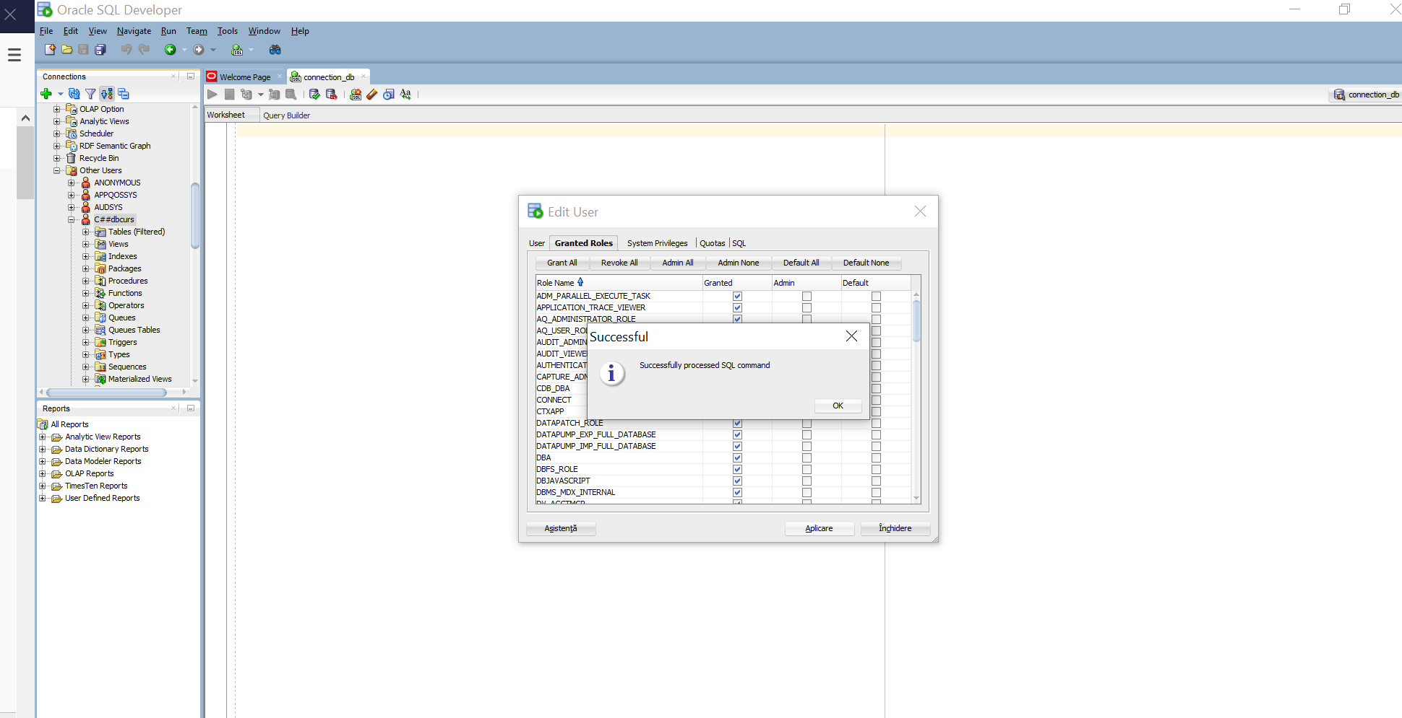

ALTER USER user_name IDENTIFIED BY new_password;

ALTER USER c##dbcurs IDENTIFIED BY "password";

To assign new privileges to an u.

grant all privileges to dac;

If you don’t install Oracle DB, you can use for now Live SQL https://livesql.oracle.com/apex/f?p=590:41:17475995580722:::41:P41_ID:148405776030629168359882238551164482016